THE SPEECH AND LANGUAGE WORKSHOP
Cardinal Primary School, Cardinal Road, Feltham. Middlesex. TW13 5AL.
Tel: 020 8890 6306 Teacher in Charge: Russell Lacey
Email: rlacey4.313@cardinalprimaryschool.co.uk
LANGUAGE GROUPS (Reception, Year 1 and Year 2) REFERRAL PACK
Before beginning the referral process, please answer these questions:
Yes / No
Is the pupil you’re thinking of referring:
generally well behaved?
cooperative in learning situations?
able to pay attention to adult led activities for an expected length of time?
able to cope with separation from parents / carers?
able to cope with social situations e.g. carpet time and role play?
likely to be able to cope well with the journey to and from the workshop? For example, they don’t suffer from travel sickness?
Referring to the reception or KS1 language group:
are their language skills (understanding questions and answering them in sentences) your main concern?
is their speech intelligible?
Are the parents of the child you’re thinking of referring:
very likely to understand the commitment to the placement of one school year?
very likely to regularly complete homework / work on targets?
very likely to ensure a good level of attendance?
very likely to attend meetings e.g. scheduled parent meetings?
If you answered ‘no’ to any of the above but still think the pupil would be a good candidate for the workshop, we advise you contact us before completing the referral forms.

School Staff Questionnaire
To support referral to The Speech and Language Workshop
Please fill out as thoroughly as possible for the individual in question. Please do not use duplicate responses if referring more than one child.

Name of child_______________________________________________

Name of school staff completing the questionnaire: |  | Relationship to child:  (SENCo / Class teacher / LSA / TA etc)

Are you referring to:  - Reception language  - KS1 language | If referring to the speech group, use the other referral pack  YES / NO
Are your primary concerns about the student:  Their speech sounds (ability to produce sounds correctly)  or  their language (understand questions and ability to speak in sentences) | A child for the speech group should have good language skills. A child for a language group should be intelligible.
Attention and Listening  - Can the child attend to a whole class activity? For how long?  - Can the child attend to 2-3 consecutive activities in a small group? For how long? | A child should be able to pay attention to something adult led for 5-10 minutes.
Play
Describe their social level of play- do they approach others to play /let others join in their play / play alongside?

Understanding of Language  - What is the severity of difficulty / your concern? On a scale from 0 (no concerns) to 5 (highly concerned)  - What is the impact in school environment?  - Does the student understand / follow the daily routine of the classroom / school?  - What instructions can they follow at school? Can they follow multiple step instructions in the classroom e.g. ‘go and get your hat and coat and line up at the door’?  - Can they answer basic ‘wh?’ questions such as ‘who/what happened/where’ | A child for the speech group should have good language skills. A child for a language group should be intelligible.
Speaking in sentences (not speech sounds)
- What is the severity of difficulty / your concern? On a scale from 0 to 5
- What is the impact in school environment?
- Is the student using single words, short phrases, or sentences to communicate?
- Do they have difficulty with sentence structure /length / grammar?
Speech (sound production)
- Would you say you understand the student 100%, 75%, 50% 25% of the time?
- What is the impact in school?
Social Communication  - Does the child cooperate with learning activities?  - Does the student have tantrums in school?  - Does the student display disruptive attention seeking behaviours?  - Does the student respond to communication /interaction with you/someone familiar?  - Does the student respond to communication /interaction from someone unfamiliar? | A child should be cooperative and generally well behaved. A child with ASD / traits of ASD or similar can still be referred as long as those difficulties do not impact on their participation on learning activities and school based social interactions.
What support has been in place for the pupil? Has the pupil made progress as a result of the support given?
Do you have any further comments that would help us make a decision as to whether to offer them a place?
Is the child known to any other professionals?
For example occupational therapist, educational psychologist, child development team, CAMHS
Please give details?

Have any other referrals been made?

Informal language assessment for The Speech and Language Workshop
Child’s name:
Person completing and role:
Please explain you would like answers in sentences if possible. You could say you would like answers with more than one word.

Part 1 When they are playing or working:
What are you doing? (please also write if what they said was correct)

The following should be asked in a quiet space away from distractions
Part 2 – Questions about themselves
What’s your name?

How old are you?

Do you have any brothers or sisters?

What did you do at the weekend?

What did you eat for breakfast today?

What did you do this morning?

What do you like doing in school?

What do you like doing at the park?

What do you like doing at home?

Part 3 What did they do in pictures
Explain: If someone asked me, ‘what did they do?’ I would say, “They jumped in muddy puddles in the garden.”


What did they do?
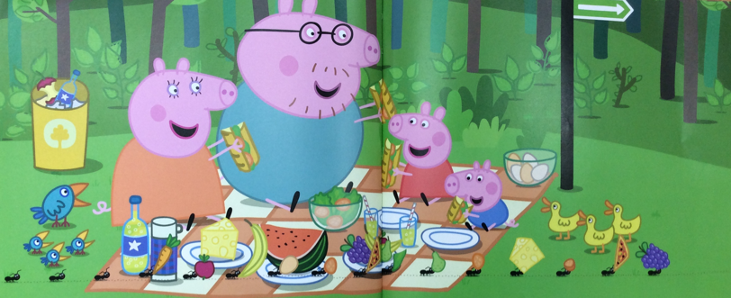

What did she do?


What did she do?


What did he do?


Part 4 Feelings

How did he feel?
Why did he feel (that way)?
How do you know he felt (that way)?

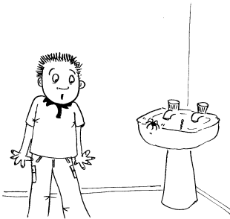
How did he feel?
Why did he feel (that way)?
How do you know he felt (that way)?

Part 5
Read to the child:
It is a very hot day. Billy is at the beach with his mum. Billy is wearing swimming shorts and a hat. Billy’s mum is sitting under an umbrella reading a book. Billy is building a really big sandcastle. He wants to find some shells to put on the sandcastle.
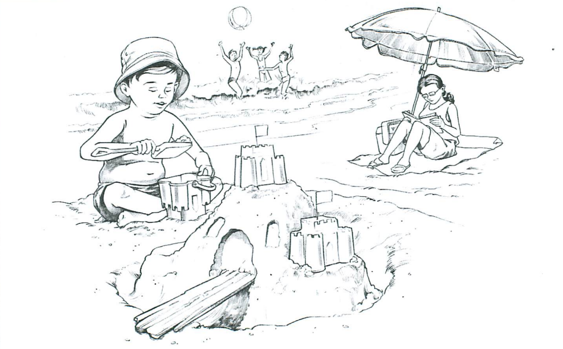
Where is Billy?

What is Billy doing?

What is his mum doing?

What are the other children doing?

What is a beach?

Why is Billy wearing his hat?

Tell me something Billy is not doing.

How is Billy making the sandcastle?

THE SPEECH AND LANGUAGE WORKSHOP
Cardinal Primary School, Cardinal Road, Feltham. Middlesex. TW13 5AL.
Tel: 020 8890 6306 Teacher in Charge: Russell Lacey
Email: rlacey4.313@lgflmail.org

REQUEST FOR PLACEMENT
Indicate the group the pupil is being referred to:
Reception Language Group This group is for children in reception in September 2026 who need support to understanding questions and how to answer them.
KS1 Language Group This group is for children in year 1 and 2 in September 2026 who need support to understand questions and how to answer them.
PUPIL INFORMATION:
Pupil Name: | Date of Birth:
Gender: | Home Language:
Address:
Name & Address of G.P. Their GP does not need to be in Hounslow.

PARENT/CARER INFORMATION
Full name:  Relationship to child: | Full name:  Relationship to child:
Address: (if different from above) | Address: (if different from above)
Telephone: | Telephone:
Email: | Email:
Do the Parent/s / carers support this referral?

Referral Made By:
SCHOOL INFORMATION
School Name: | Head Teacher Name:
Address: | Class Teacher Name:
Address: | Speech & Language Therapist Name if applicable:
Telephone: | SENDCO Name:  SENDCO email address:

Any Supporting Comments:

Please return to The Speech & Language Workshop by Friday 15th May 2026.

