THE SPEECH AND LANGUAGE WORKSHOP
Cardinal Primary School, Cardinal Road, Feltham. Middlesex. TW13 5AL.
Tel: 020 8890 6306 Teacher in Charge: Russell Lacey
Email: rlacey4.313@cardinalprimaryschool.co.uk
SPEECH GROUP (Reception and Year 1) REFERRAL PACK
Before beginning the referral process, please answer these questions
Yes / No:
Is the pupil you’re thinking of referring:
generally well behaved?
cooperative in learning situations?
able to pay attention to adult led activities for an expected length of time?
able to cope with separation from parents / carers?
able to cope with social situations e.g. carpet time and role play?
likely to be able to cope well with the journey to and from the workshop? For example, they don’t suffer from travel sickness?
Referring to the speech group:
are their speech sounds your main concern?
are their language skills broadly within age related expectations?
will the child be in reception or year 1 in September 2026?
Are the parents of the child you’re thinking of referring:
very likely to understand the commitment to the placement of one school year?
very likely to regularly complete homework / work on targets?
very likely to ensure a good level of attendance?
very likely to attend meetings e.g. scheduled parent meetings?
If you answered ‘no’ to any of the above but still think the pupil would be a good candidate for the workshop, we advise you contact us before completing the referral forms.
School Staff Questionnaire
To support the referral to The Speech and Language Workshop
Please fill out as thoroughly as possible

Name of child_______________________________________________

Name of school staff completing the questionnaire: |  | Relationship to child:  (SENCo / Class teacher / LSA / TA)

Are you referring to:  - Speech sounds group ? | If referring for the language groups, please use the other referral pack  YES / NO
Are your primary concerns about the student:  Their speech sounds (ability to produce sounds correctly)? | A child for the speech group should have good language skills. A child for the speech group would have a number of phonological error patterns making their speech unintelligible to the listener.  YES / NO
Attention and Listening  - Can the child attend to a whole class activity? For how long?  - Can the child attend to 2-3 consecutive activities in a small group? For how long? | A child should be able to pay attention to something adult led
Play
Describe their social level of play- do they approach others to play /let others join in their play / play alongside?

Understanding of Language  - What is the severity of difficulty / your concern? On a scale from 0 (no concerns) to 5 (highly concerned)  - What is the impact in school environment?  - Does the student understand / follow the daily routine of the classroom / school?  - What instructions can they follow at school? Can they follow multiple step instructions in the classroom e.g. ‘go and get your hat and coat and line up at the door’?  - Can they answer basic ‘wh?’ questions such as ‘who/what happened/where’ | A child for the speech group should have good language skills in order to understand the work we do to improve speech production.
Speaking in sentences (not speech sounds)
- What is the severity of difficulty / your concern? On a scale from 0 to 5
- What is the impact in school environment?
- Is the student using single words, short phrases, or sentences to communicate?
- Do they have difficulty with sentence structure /length / grammar?
Speech (sound production)
- Would you say you understand the student 100%, 75%, 50% 25% of the time?
- What is the impact in school?
Social Communication  - Does the child cooperate with learning activities?  - Does the student have tantrums in school?  - Does the student display disruptive attention seeking behaviours?  - Does the student respond to communication /interaction with you/someone familiar?  - Does the student respond to communication /interaction from someone unfamiliar? | A child should be cooperative and generally well behaved. A child with ASD / traits of ASD or similar can still be referred as long as those difficulties do not impact on their participation on learning activities and school based social interactions.
What support has been in place for the pupil? Has the pupil made progress as a result of the support given?
Do you have any further comments that would help us make a decision as to whether to offer them a place?
Is the child known to any other professionals?
For example occupational therapist, educational psychologist, child development team, CAMHS
Please give details?

Have any other referrals been made?

Speech assessment for The Speech and Language Workshop referral
Please try to record exactly how the pupil said each word

Pupils name:_______________________________________________________
Name and role of person who carried out this assessment:
This isn’t a test of vocabulary or understanding of questions. It is assumed children being referred to the speech group have a good understanding of language. This does not need to be completed in one go. This is a test of how the child says sounds in different places in words. You can show the child objects or different pictures if you prefer. You could ask different questions for different words / pictures e.g. What is that? What colour is that? What is that person doing? What animal is that? What are these?
Word | Initial response.  Show the child the picture / object and write down what they say, how they say it. | Production after modelling.  Tell the child to repeat the word after you and write down what they say, how they say it.
Pencil
Apple
Sheep
Boat
Baby
Crab
Mouse
Hammer
Drum
Net
Banana
Lion
Window
Flower
House
Table
Scooter
Cat
Dice
Ladder
Bed
Key
Bucket
Book
Gate
Lego
Dog
Fingers
Ring
Yellow
Feet
Elephant
Knife
Van
River
Glove
Sock
Castle
Dress
Zebra
Lizard
Cheese
Leaf
Jelly
Bell
Shoe
Mushroom
Fish
Chips
Ketchup
Torch
Jam
Hedgehog
Bridge
Rabbit
Mirror
Treasure
Thumb
Bath
Feather
Present
Plug
Bread
Blue
Train
Twelve
Dragon
Queen
Crane
Clock
Green
Glasses
Frog
Flag
Spider
Smile / smiling
Snail
Sweets
Stairs
Scarf
Slide
Three

 |  | 
 |  | 
 |  | 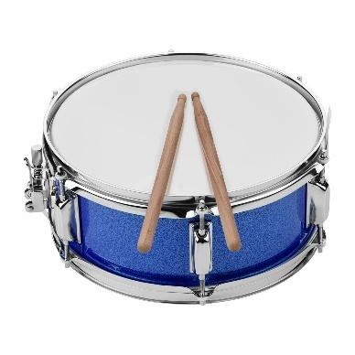
 |  | 
 |  | 
 |  | 
 |  | 
 |  | 
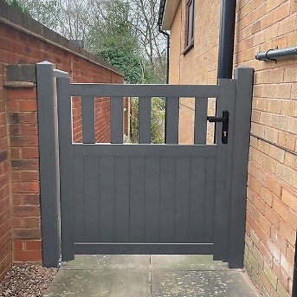 |  | 
 |  | 
 |  | 
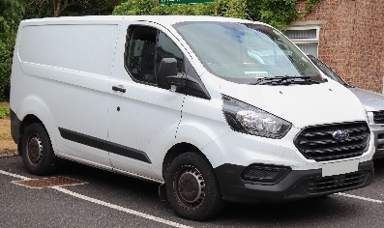 |  | 
 |  | 
 |  | 
 |  | 
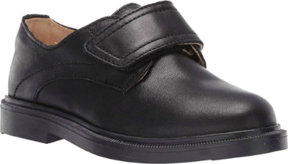 |  | 
 |  | 
 |  | 
 |  | 
 | 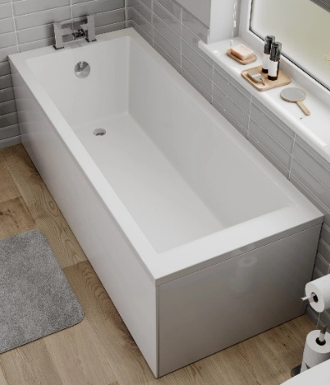 | 
 |  | 
 |  | 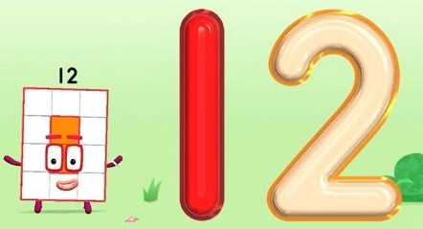
 |  | 
 |  | 
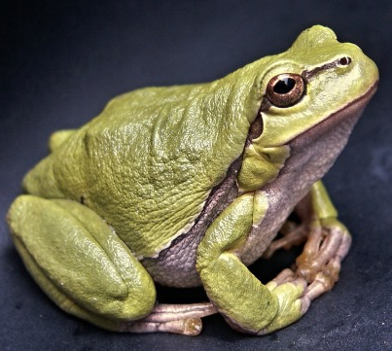 |  | 
 |  | 
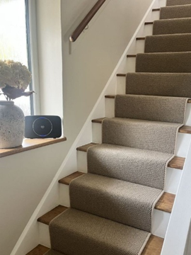 |  | 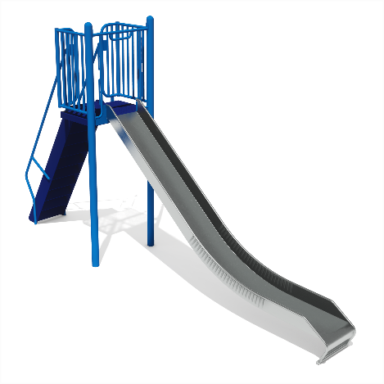


THE SPEECH AND LANGUAGE WORKSHOP
Cardinal Primary School, Cardinal Road, Feltham. Middlesex. TW13 5AL.
Tel: 020 8890 6306 Teacher in Charge: Russell Lacey
Email: rlacey4.313@lgflmail.org

REQUEST FOR PLACEMENT
Group the pupil is being referred to:
Speech (speech sounds production) This group is for children in reception and year 1 in September 2026 who need to work on their speech sounds.
PUPIL INFORMATION:
Pupil Name: | Date of Birth:
Gender: | Home Language:
Address:
Name & Address of G.P. Their GP does not need to be in Hounslow.

PARENT/CARER INFORMATION
Full name:  Relationship to child: | Full name:  Relationship to child:
Address: (if different from above) | Address: (if different from above)
Telephone: | Telephone:
Email: | Email:
Do the Parent/s / carers support this referral?

Referral Made By:
SCHOOL INFORMATION
School Name: | Head Teacher Name:
Address: | Class Teacher Name:
Address: | Speech & Language Therapist Name if applicable:
Telephone: | SENDCO Name:  SENDCO email address:

Any Supporting Comments:

Please return to The Speech & Language Workshop by Friday 15th May 2026.

